Hi WILLIAM,
Member ID# 1949406357
Birth Month: May
1895 SCHOETTLER VALLEY DR
CHESTERFIELD, MO

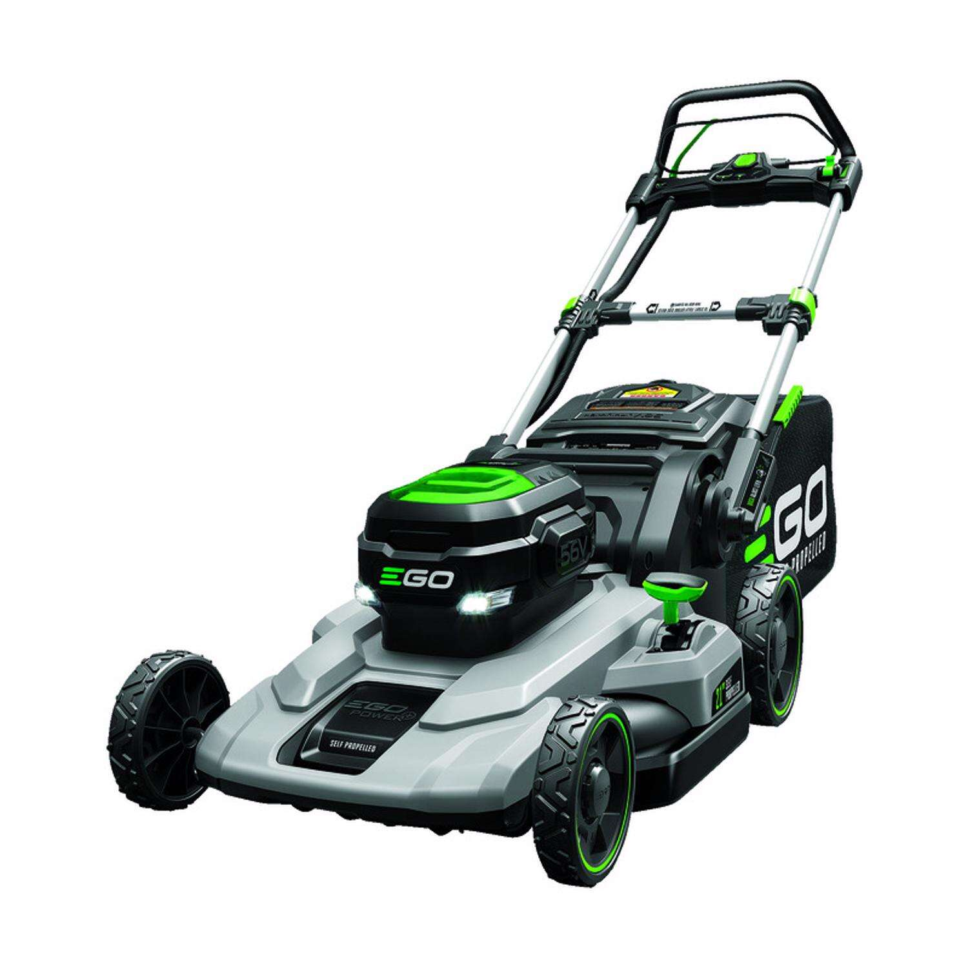

EGO Power+ LM2102SP 21 in. 56 V Battery Self-Propelled Lawn Mower Kit (Battery & Charger) W/ 7.5 AH BATTERY
Item #7804826| Mfr #LM2102SP
(6480)Write Review|Questions & Answers (6)
$599.00

